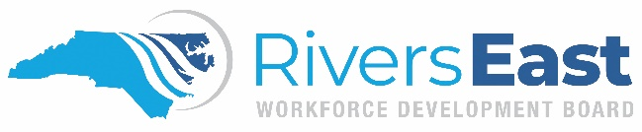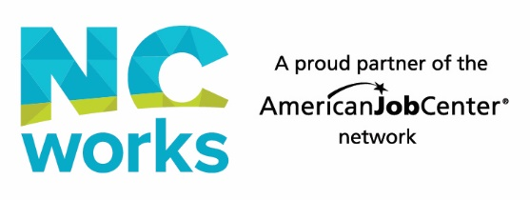NCWorks-NextGen_logo_cmykPersonally Identifiable Information

Release Form

As a part of the Workforce Innovation and Opportunity Act(WIOA) intake and eligibility process, we are required to ask and document certain Personally Identifiable Information such as, but not limited to, your social security number, birth date, age, home telephone number, marital status, spouse name, educational history, and financial information.

We are required to inform you that our agency will take the steps necessary to ensure the privacy of all Personally Identifiable Information obtained from you and/or other organizations on your behalf and to protect such information from unauthorized disclosure. Your data and personal information will be stored in an area that is physically safe from access. Information collected will be used for grant purposes only.

I acknowledge that the above information has been discussed with me and that I am aware that my Personally Identifiable Information is being collected and will be used for grant purposes only.

\_\_\_\_\_\_\_\_\_\_\_\_\_\_\_\_\_\_\_\_ \_\_\_\_\_\_\_\_\_ \_\_\_\_\_\_\_\_\_\_ \_\_\_\_\_\_\_\_\_\_\_\_

Applicant Signature Date Staff Signature Date

\_\_\_\_\_\_\_\_\_\_\_\_\_\_\_\_\_\_\_\_\_\_\_\_\_\_\_\_\_\_\_\_

Parent/Guardian Signature Date

(If applicant is under 18 years of age)

*Equal Opportunity Employer/Program.*

*Auxiliary aids and services available upon request to individuals with disabilities.*