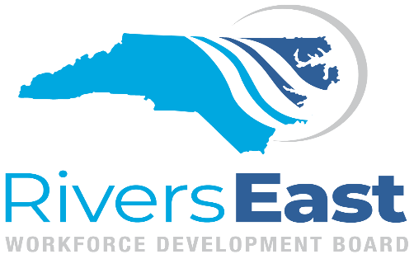

NC Works Committee Meeting

AGENDA
May 11, 2021
1:00PM - 2:30PM
via ZOOM

NCWorks Committee Function /Mission
The NCWorks Committee will provide information and assist with operational and other issues relating to the one-stop delivery system (NCWorks Career Centers), which may include as member representatives of the one stop partners. This committee will also oversee the implementation, designation, certification and operation of the NCWorks Career (One-Stop) Centers throughout the LA as specified under WIOA. Oversight includes site visits, approval of fiscal expenditures of each Center, analysis and evaluation of performance indicators, such as customer satisfaction rate, business penetration rate, and employment rate, earnings/retention of customers and recommendation of corrective action as appropriate.

Call to Order
1:00 Determination of a Quorum Mary H. Paramore, Chair

1:05 Consent Agenda*
Approval of the March 9, 2021 Minutes
Fund Management Report
Performance Reports

1:10 Performance Improvement Plan Review* Jennie Bowen, Director

1:40 Funding Recommendation* Lou Stout, Compliance Manager

1:50 Outreach/Social Media Efforts Ashlan Sawyer, Strategic Initiatives Coordinator

2:00 Best Practices- Hiring Events Callie Northern-Herring, Center Manager

2:15 One Stop Operator Report John Powell, One-Stop Coordinator

2:30 Other Business

Adjourn

