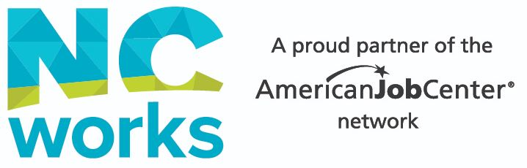

Career Research & Exploration
Customer Name:_______________________________________________ Date: __________________
Training Program Requested: ____________________________________________________________
Career Title
# Current Job Openings
Average Local Salary
Education Requirements
Licenses / Certifications

How far are you willing to commute for work? _____________________ Are you willing to relocate after graduation? ____ Yes ____ No
List 3 resources where you can locate jobs listed for this field, with one being NCWorks.gov:
- NCWorks.gov ______________________________________________________________________
- __________________________________________________________________________________
- __________________________________________________________________________________

Describe the typical duties involved with this career field.

Based on your research, what skills and qualifications are employers requiring for this career?

What is the typical work experience requirement? Are there openings that do, or will match your experience/education?

What resources did you use to research this career?
□ ONET □ NCCareers.org □ MySkillsMyFuture □ ___________________ □ ___________________

I have reviewed this form with the customer listed, verified the information, and the research correlates with the customers Traitify results and career goal.

Career Advisor________________________________________________________ Date______________

Equal Opportunity Program/Employer. Auxiliary aids and services are available upon request to individuals with disabilities.
REWDB 12/2021

