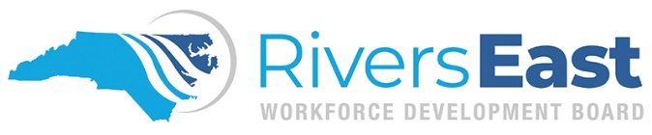

Incumbent Worker Goal Attainment Report

Business: Click or tap here to enter text.

- Please give a short narrative of competencies the trainees received for each training.

- Explain how the above competencies will result in increased productivity, efficiency, profitability, competitiveness, etc. of your establishment.

- What are the short-term and long-term benefits of this training for your establishment?

- Did any trainees retain their employment at your business solely as a result of the training?
☐ Yes ☐No
Comments:

- Have/will any of the trainees receive additional compensation as a result of their increased skills?
☐Yes ☐No
Comments:

- Did any trainee advance to other job positions or perform other advanced job responsibilities as a result of the training?
☐Yes ☐No
Comments:

- Was the training topic aligned to the needs outlined in your Local Incumbent Worker application?

☐Yes ☐No
Comments:

- Explain the degree in which the training provider satisfied these needs.

- Would you recommend the training topic and training provider to another business?
☐ Yes ☐No
Comments:

- Was any of the training provided through Local Area Incumbent Worker grant available from a publicly funded local community college or university?
☐ Yes ☐No
If yes, and you did not choose that source as a training vendor, please explain why:

- Would you recommend Local Area Incumbent Worker grant to other businesses?
☐Yes ☐No
Comments:

- Do you have additional workforce needs for current or future employees that you would like to discuss with (Insert Local Area Name here) Workforce Development Board?

