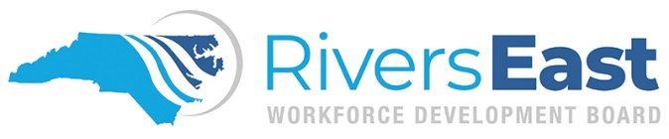

Incumbent Worker Training Program

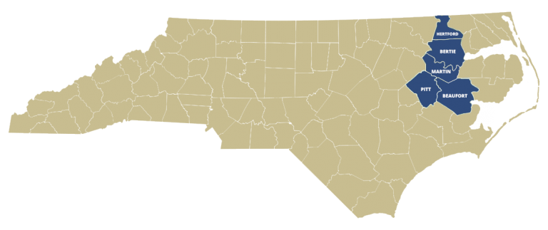

Policy and Program Guidelines

Program Year: July 1, 2021 to June 30, 2022

Rivers East Workforce Development Board
Mid-East Commission
1502 N Market St, Suite A
Washington, NC 27889
252-946-8043

Funded through the Workforce Innovation and Opportunity Act
An Equal Opportunity/Affirmative Action Employer/Program. Auxiliary aids and services available upon request to individuals with disabilities.
Policy and Guidelines

Incumbent Worker Training Grants (IWG) are designed to meet the special requirement of an employer to retain a skilled workforce or avert the need to lay off employees by assisting the workers in obtaining the skills necessary to retain employment. All grants are funded through the Workforce Innovation and Opportunity Act (WIOA). Provided funding is available, the Rivers East Workforce Development Board (WDB) will designate $60,000 per program year to IWGs.

Incumbent Worker Training Guidelines:

- Incumbent workers must have a skills gap. These skills gaps can be a result of an incumbents changing responsibilities and/or requirements in her/his job, or for an employee whose job may potentially be eliminated and skill upgrading is needed to accept new responsibilities.

- The training(s) should result in increased knowledge/skills or wages for the employee and increase the stability and competitiveness of the employer.

- Trainings that results in or provides a significant step towards achieving an industry-recognized certification/credential will receive preference.

- North Carolina for profit and not-for-profit businesses that have been in operation in North Carolina for a minimum of twelve-months (12) are eligible to apply; eligible employees must have been employed for a minimum of six-months.

- The maximum grant amount per award is $10,000. Beginning September 1, 2021, the lifetime limit for businesses will be $100,000 per two-year cycle. Collaborative grants with two or more businesses have a maximum award amount of $12,500; same lifetime maximum. The collaborative award amount will be equally portioned among all the businesses listed on the application.

- Businesses can submit their applications at any time during the program year to the Rivers East Workforce Development Director by completing the application and following the submission process.

- All applications are reviewed through the WDBs NCWorks Committee and then approved by the full WDB.

After the grant is awarded, a contract will be established between our administrative entity, Mid-East Commission, and the business. The business will pay for the training (in accordance with the budget set forth in their application) and be reimbursed once the training has been completed.

Application Process

Eligible businesses can apply at any time during the program year by completing the Grant Application.
Once completed, the business will forward to the WDB. The business will receive a notice within 48 hours of the application being received with an estimated time of when the Review Committee will meet. Once a final decision is made, the WDB will notify the business within 48 hours and provide any additional feedback, if applicable.

What happens after a business is awarded a grant?

- A contract is established between Mid-East Commission (the Administrative Entity for the WDB) and the business within a month following the WDBs approval.
- Mid-East Commission holds the funds for the training until the training is complete. Training must be completed within 12 months from the date of the contract.
- On or before the training begins, the employer will submit a Trainee Application for each employee.
- After completion of the training, the business will submit:
  - a reimbursement request (with their invoice and proof of payment to the training provider);
  - a goal attainment report; and
  - a trainee roster.

If there is an extenuating circumstance that leads to a need to request a change to the approved training, the business must contact the WDB to discuss the best alternatives. Changes in the training(s) will not necessitate a new application but the business will need to complete an amended training form and submit to the WDB as soon as possible. If necessary, the WDB may convene the grant review committee to review these changes as it relates to the purpose of this grant, including the trainees’ originally identified skills gaps. The training will still need to be completed within the one-year timeframe.

Can a business apply for a grant that will serve different, multiple businesses with common training needs?

Yes, unique businesses can collaborate and apply for a collaborative training grant. The proposal for the common request must:
- Train employees of at least two different businesses, with one of those businesses designated as the Lead Applicant;
- Include employees of the Lead Applicant in the training;
- Include training descriptions and outcomes that address the employees from all businesses impacted by the proposed common training
- Include information on each business that will be part of the training. The application has a specific section for this information

Is the business required to contribute to the cost of the training?

The employer or group of employers must pay for a portion of the cost of providing the training to their employees. This portion is defined as the non-federal share. The non-federal share shall be:

- not less than 10% of the cost for employers with not more than 50 employees;
- not less than 25% of the cost, for employers with more than 50 employees, but not more than 100 employees; and
- not less than 50% of the cost, for employers with more than 100 employees.
The non-federal share may include the amount of wages paid by the employer to a worker while the worker is participating in training. The employer may provide the share in cash or in kind, fairly evaluated. Other examples of an employer’s non-federal share are training equipment purchases, onsite facility usage, employees’ food, travel, or lodging. The business will be required to calculate its actual non-federal share at the conclusion of the training. Should the non-federal share not meet the limits, the funds could potentially need to be repaid.

Expected Program Outcomes

At the completion of the grant, businesses will be asked to provide the following:

- Participants wage gain
- Participants employment retention
- Participants training completion
- Other outcomes deemed appropriate and noted in the contract

What employees are eligible?

Eligible employees are:
- at least 18 years of age and a paid employee of the applicant business or businesses;
- in a relationship that meets the “Fair Labor Standards Act” for an employer-employee (meaning the employee receives a W-2 from the employer);
- an employee with an established employment history with the employer for six (6) months or more;
- a citizen of the United States or a non-citizen whose status permits employment in the United States; and
- an employee to be trained who works at a facility located in North Carolina.

Who is not eligible to attend training?

- anyone who receives a 1099 Form; or
- those who are placed through a temporary agency.

Eligible Business

- is a North Carolina for-profit or not-for-profit business;
- be current on all federal, state and local tax obligations;
- has an employer-employee relationship with at least five (5) employees;
- have been in operation in North Carolina 12 or more months; and
- is financially viable.

In addition, the business must agree to provide the WDB the following information on each employee application:

- Complete Name
- Contact Information
- Social Security Number
- Gender
- Date of Birth
- Citizenship (Right-to-Work Status)
- Selective Service Compliance (Males only)
- Ethnicity and Race
- Highest School Grade Completed
- Highest Education Level Completed
- Disability Status (if disclosed)

All eligible employees must have an NCWorks.gov online account to participate. Assistance and/or instructions will be provided as requested.

What businesses are not eligible to apply?

The following businesses are not eligible to apply for funds under this program:
- A business that is currently receiving training funds, either directly or indirectly, from North Carolina state government (unless those training funds do not duplicate the training efforts outlined in this grant application). This includes trainings offered at no cost through the Small Business Technology Development Center (SBTDC) or the NC Community College’s Customized Training program;
- A business that has received funds either directly or indirectly from North Carolina state government under any previous training initiative, and the terms of the agreement for training have not been met;
- A Workforce Development Board or its administrative entity;
- A labor union; or
- A government entity, including publicly-funded organizations.

