Determining if an Individual Lives in a High-Poverty Area Based on Their Street Address
Based on WIOA regulation 20 CFR 681.260 the poverty rate must be 25% or higher for the participant to meet the requirements of “living in a high poverty area”.

Step 1 - Click on https://geocoding.geo.census.gov/geocoder/geographies/address?form. You will use the FIND GEOGRAPHIES SECTION – which should be selected for you, by default.
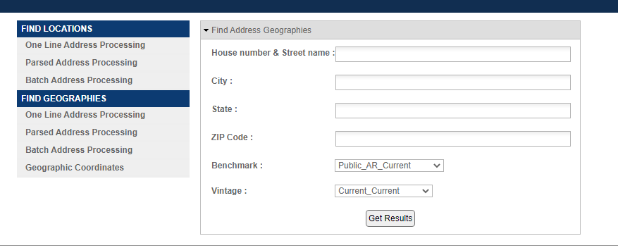

Step 2 – Type in the street address, city and state. Zip code is not required and click “Get Results”. You DO NOT need to change anything with “Benchmark” or “Vintage”.
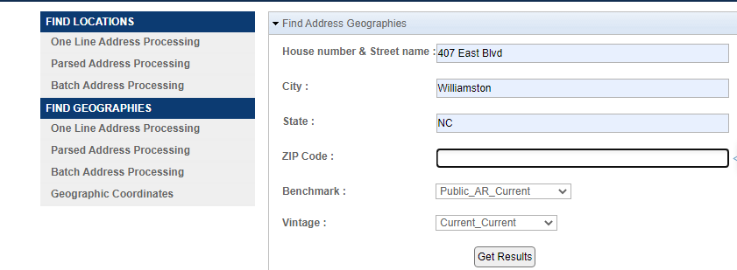

Step 3 – The “Results” will return a long list of items. You will need to scroll down until you find the section “Census Tract”. You are looking for the highlighted area “NAME: Census Tract XXX”. You will need to write down or keep your tab open, as you will need this number in the next step.
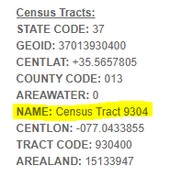
Step 4 – Click on https://www.census.gov/acs/www/data/data-tables-and-tools/narrative-profiles/
It will default to 2019. You are going to select “Census Tract”. From the dropdown boxes, you will select the “state”, “county”, and the “Census Tract Number” from Step 3.
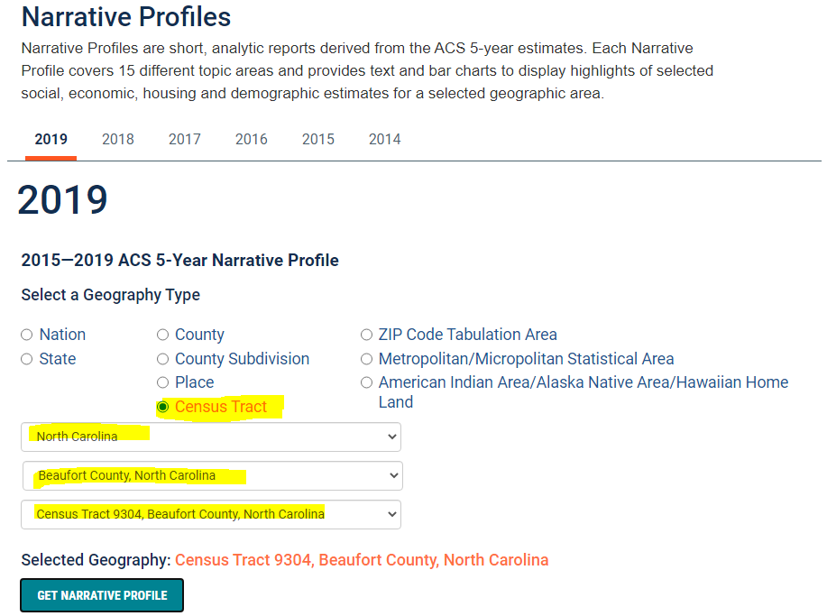
Once you have selected those four (4) items, click the green “GET NARRATIVE PROFILE” button.

Step 5 – Once the Narrative Profile is displayed on the screen, scroll down until you find the “Poverty and Participation in Government Programs” Section.
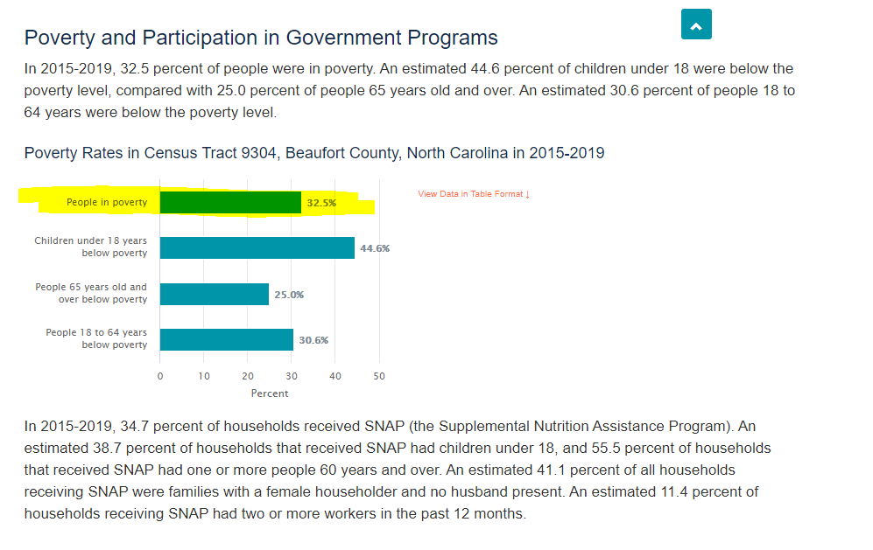

You will need to use the percentage listed in the “People in Poverty” line. If the percentage is 25% or higher, the individual lives in a high poverty area. Any percentage under 25%, the individual does not qualify as being in a high poverty area.

Step 6 – ONLY IF YOU CANNOT FIND THE ADDRESS IN STEP 1
If you cannot find the address in Step 1, you can click on the link below to be taken to the Census Track maps to find the Census Track Number.
https://www2.census.gov/geo/maps/DC2020/PL20/st37_nc/censustract_maps/

If you cannot locate the address by either method, please contact the Local Area and we will assist you in determining how to move forward.

