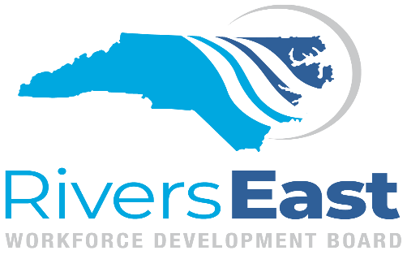

NC Works Committee Meeting

AGENDA
May 11, 2022
1:30PM - 3:00PM
via ZOOM

NCWorks Committee Function /Mission
The NCWorks Committee will provide information and assist with operational and other issues relating to the one-stop delivery system (NCWorks Career Centers), which may include as member representatives of the one stop partners. This committee will also oversee the implementation, designation, certification and operation of the NCWorks Career (One-Stop) Centers throughout the LA as specified under WIOA. Oversight includes site visits, approval of fiscal expenditures of each Center, analysis and evaluation of performance indicators, such as customer satisfaction rate, business penetration rate, and employment rate, earnings/retention of customers and recommendation of corrective action as appropriate.

Call to Order
1:30 Determination of a Quorum Vivian Saunders, Chair

1:35 Consent Agenda Chair
Approval of the January 12, 2022 Minutes
Operator Performance Report

1:40 Funding Recommendations* Lou Stout, Compliance Manager

1:45 PY’22 Procurement Results* Lou Stout, Compliance Manager

2:00 Revised Supportive Services Policy* Lou Stout, Compliance Manager

2:15 One Stop Operator Report John Powell, One-Stop Coordinator

2:30 Addition of Resource Members Vivian Saunders, Chair

Other Business

Adjourn

