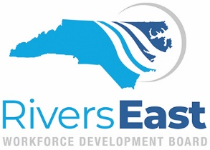

AGENDA
Wednesday, May 11, 2022
3:00 PM
Via ZOOM

The purpose of the Rivers East Workforce Development Board is to provide regional leadership, guidance and support to meet the changing needs of our communities through strategic innovation and collaboration.

3:00 Call to Order Robert Williams, Chair
Determination of a Quorum

3:05 Consent Agenda Robert Williams, Chair
Approval of March 9, 2022 Minutes
Operator Performance Reports

3:10 Committee Reports-
Youth/NEXTGEN Committee Report* Trey Goodson, Committee Chair
*Policy Updates
NCWorks Committee Report* Vivian Saunders, Committee Chair
*PY’22 Procurement
*Policy Update
*Funding Recommendations
Inclusion Committee Report Larry Donley, Committee Chair

3:45 Update on NCWorks Commission’s Proposed WDB Realignment Jennie Bowen, Director

4:05 Nominating Committee Robert Williams, Chair

4:15 Strategic Initiatives Updates & Activities Ashlan Crouch, Strategic Initiatives Coordinator
4:20 Meeting Schedule for 2022-2023

Other Business

Adjourn

