**RIVERS EAST ONLINE & ASSISTIVE TECHNOLOGIES TOOLS – GENERAL INSTRUCTIONS**

Updated July 5, 2022

1. **ACT Workkeys, Workkeys-Aligned, and Essential Skills Curriculum** and assessments are based on situations in the everyday working world. They are supported by data from more than 20,000 job skills profiles and rooted in decades of workplace research. The online courses (curriculum) upskill the customer in specific areas and prepare them for assessments that measure “hard” and “soft” skills.

Please keep in mind that the National Career Readiness Certificate (NCRC) initiative is a portable, nationally recognized credential that can help individuals get the job they want. The certificate focuses on certifying three essential skills- Applied Math, Graphic Literacy, and Workplace Documents.

* 1. New to ACT Workkeys? Please click [HERE](https://www.act.org/content/act/en/workforce-solutions/act-workkeys/act-workkeys-curriculum.html#:~:text=ACT%C2%AE%20WorkKeys%C2%AE%20Curriculum,skills%20critical%20to%20workplace%20success.&text=It's%20the%20only%20curriculum%20built,Readiness%20Certificate%20(NCRC%C2%AE).) to learn more about the program.

* 1. Pasted below are the courses that we are able to offer through the Rivers East WDB license.

* 1. ACT offers several online tools for users including:
     + The user guide and training videos:  <https://www.act.org/content/act/en/products-and-services/workkeys-for-workforce-developers/curriculum.html>
     + On-demand ACT Workkeys Curriculum Training 3.1.19 at:  <https://event.on24.com/eventRegistration/EventLobbyServlet?target=reg20.jsp&referrer=https%3A%2F%2Fwww.act.org%2F&eventid=1950219&sessionid=1&key=90FCF72E90D552374111D52040102EC2&regTag=&V2=false&sourcepage=register>

* 1. The Rivers East WDB Initiative is for curriculum only. When customer is ready for NCRC testing, please refer to local community college.
  2. For NCRC,
     + Recommend starting with *Workkeys Curriculum Quick Guide* to determine level of training needed for customer. Upon completion of the assessment, the system will recommend whether the customer is ready to start Workkeys Curriculum Levels 3-7 for Applied Math, Graphic Literacy and Workplace Documents; or if customer needs to start with basics, Workkeys Curriculum Levels 1-2.
     + NCRC is issued at four levels:
     + Bronze - 3
     + Silver - 4
     + Gold - 5
     + Platinum - 6/7
  3. For quick reference, the account hierarchy is as follows:
* Rivers East WDB is the “Institution”
* Each NCWorks Career Center is the “Group” and listed as Beaufort Team, Hertford Team, Martin/Bertie Team, & Pitt Team.
* The Center Managers, Career Team Executive Director, Career Team Adult/DW and Youth Program Managers, and Rivers East Workforce Development Board staff are set up as “Institution Admin/Supervisors*”*; duties include:
  + Manage groups
  + Create “Instructor” accounts
  + Create customer (student) accounts
* Career advisors are set up as “Instructors”; duties include:
  + Assign courses for customers
  + Monitor customers’ progress and assist them with platform as needed
  + View/export customer reports
  + Provide “Institution Admin/Supervisor’” with customer names and email addresses to create student accounts

* 1. To set up, career advisor will receive a system-generated invitation to set up account including password.  Please check your junk mail if you can’t find it.  *(Note - if you used your current email address (e.g.,/@careerteam.com) to secure your NCRC with another institution, the system may prevent you from registering with the Rivers East account.  Contact ACT Support at* [workkeyscurriculum@act.org](mailto:workkeyscurriculum@act.org) if *need assistance with a password reset or establishing your account.)*You will then be able to explore and learn about the software features.  If you have customers that are ready to start on their NCRC, for example, Pat Harris will be available to help create student accounts as needed.
  2. How to assign your customers (students) to your Group/Team (e.g. Martin/Bertie Team).

ATTN Administrators: after adding a student to WorkKeys, you should also add the new student to the Group/Team so the student becomes visible to the Instructors in the Group/Team.

First click on <Groups> in left navigational bar. Find and hover over your Group/Team name and click the arrow >> that will appear to far right.

Once the details page is visible for your Group/Team, click <Students> and then <Manage>

Click <All Available Students> tab; find the student that was added and check box to left of name; click <Add to Group> and then <Save to Group>. Student should now appear in your Group/Team.

1. **Assistive Technologies** are available at each career center to individuals with hearing, visual, mobility and/or other impairments to enable better access to services. All staff is required to become proficient at using this equipment.
   1. C-Pen Exam Reader - "*is a robust, pocket-sized reading pen. No special access arrangements required. This pen is ideal for hearing words and lines of text read aloud; great for students with dyslexia, reading difficulties and English as a second language; designed to support use with headphones.*; Quick Start Download [HERE](https://cpenfiles.blob.core.windows.net/manualer/C610E%20ExamReader%20user%20guide%20(en).pdf); video link [HERE](https://www.youtube.com/watch?v=K_30f8jJ8g8).
   2. Livescribe Echo Smartpen - *"Let the Livescribe Echo Smartpen do all the work for you. This intuitive pen allows you to record over 200 hours of audio and capture thousands of pages of notes. When you're done, simply plug your pen into your PC and review your notes and listen back to your recorded audio.";* User Guide Download [HERE](https://www.livescribe.com/en-us/media/pdf/support/Echo_User/Echo_UserGuide.pdf); video link [HERE](https://www.youtube.com/watch?v=oNjSN0y5A48).; how to set up pen can be found at [HERE](https://www.youtube.com/watch?v=9Qo72cetlSY).
   3. PenFriend 3 - *This device is great for people with vision loss. The PenFriend 3 can create custom labels for various items like NCWorks documents, for example. Use the simple to operate, pen shaped device to create the label, and then whenever you bring the pen close it, you will automatically hear the voice label that you've given it;* Instruction Manual Download [HERE](http://www.vipconduit.com/terry/info/PenFriendManual.html); video link [HERE](https://www.youtube.com/watch?v=zZxd-sxvU-I).
   4. PocketTalker - *is an out-of-the-box hearing assistance solution that helps customers stay connected and involved by amplifying sounds and voices - all at a fraction of the cost of hearing aids. This device can be used with the customer's hearing aids, headphones or ear buds*; Quick Start Download [HERE](http://35pytx37zdp5j4hfr35of829-wpengine.netdna-ssl.com/atrc/wp-content/uploads/sites/25/2019/02/pocket-talker-2010.pdf); video link [HERE](https://www.youtube.com/watch?v=l1kZdDzkKYk).
   5. RollerMouse Red Plus - *When you’re using the RollerMouse Red Series, you will experience the full ergonomic benefits that come from using a central pointing device. You’ll stop reaching for the mouse, saving time and strain on your forearms, elbows, and shoulders. RollerMouse also will allow you to eliminate gripping, which can cause strain and pain in the hand*; Product Manual Download [HERE](https://www.contourdesign.com/support/product-manuals/); video link [HERE](https://www.youtube.com/watch?v=X8OPbOQaSzs).
2. **Constant Contact** messagingis used to ensure that all center staff receives information that affects them and/or their customers, including local hiring events, new programs, program changes, polices, lessons learned tips, required 2nd Friday Training and other workshops, and the list goes on. Be sure to watch for this messaging through the Rivers East WDB’s *Inside News & Updates That Affect You!*

If you are not receiving WDB’s *Inside News & Updates That Affect You!* please check your junk mail, locate the email and add to safe sender’s list. Still don’t see it? Contact Pat Harris at [pharris@mideastcom.org](mailto:pharris@mideastcom.org)

1. **eSkill** skill tests help staff to identify candidates who have the right knowledge and experience to do a specific job, as well as help management to determine internal training needs. Select from over 800 standard job-based and subject-based tests, configure tests from eSkill content to create precise tests for hiring and training. Please note that eSkill is set to expire in September 2022.
   1. What kind of assessments are available? Go to the Test Library at <https://www.eskill.com/subjects/>

* Job-based Tests Download – click [HERE](https://es.eskill.com/es/reports/api/v1/jasperreport?encryptedParams=b5736bea7b007e553a8bf277d4a9969f968bcfc32b6504d0b99113af6411795e0f5d9cbc8ecee9f42e983847c5028b5f&reportName=/Reports/AllJobBasedTests&outputFormat=pdf)
* Subject-based Tests Download – click [HERE](https://es.eskill.com/es/reports/api/v1/jasperreport?encryptedParams=9206abd7f6b73d54&reportName=/Reports/AllPredefinedNoBrandTests&outputFormat=pdf)
* Combinable Assessment Modules Download – click [HERE](https://es.eskill.com/es/reports/api/v1/jasperreport?encryptedParams=b5736bea7b007e553a8bf277d4a9969f968bcfc32b6504d0b99113af6411795ee5d2f2c3a5d01caaac04469171294637001eeb5f3c43091f&reportName=/Reports/ListOfAllSubjects&outputFormat=pdf)
  1. Please note that all center staff are assessed for MS Word & Excel skills through eSkill. New employees will be notified when assessments are scheduled.
  2. eSkill can be offered as an available business service to employers to help assess potential candidates for specific skills.
  3. Ready to test customer or hiring candidates? Contact Pat Harris at [pharris@mideastcom.org](mailto:pharris@mideastcom.org) to set up assessments.

1. **Guidance & Direction for Jobseekers manual known as GADJ,** was developed to aid frontline staff who provide career counselling. As thorough career counselling process is a continuous cycle of assessing self, exploring options, developing skills, marketing self, and performing job skills. This manual provides necessary components for comprehensive career guidance, with each component divided by age-appropriate strategies and available resources to advance opportunities.
2. GADJ is written in a “lesson plan” format for ease of delivery. Currently that are 29 lesson plans.
3. GADJ can found at: <http://riverseastwdb.org/staff-resources/guidance-direction-for-job-seekers/>
4. **Premier Virtual** is just like an in-person job fair but it utilizes a virtual event platform that connects job seekers with employers. Job seekers can review employers through their booths, apply for jobs with their resumes, and ask questions through chat and/or video-chat with employers. Employers can engage job seekers, conduct spot interview through the video-chat feature, review resumes and consider job seekers for potential employment.
   1. Interested in hosting a virtual career fair?

* Pull together a team of colleagues and partners to collaborate and formulate a plan to host a virtual fair.
* Contact Pat Harris at [pharris@mideastcom.org](mailto:pharris@mideastcom.org) so she can schedule and begin work to set up event on Premier Virtual platform.
* Determine event date and time.
* Registration:
  + Determine date to open online registration (recommend ~3-4 weeks prior to event)
  + For job seekers:
    - Determine registration questions; what data do you want to collect?
    - Require or recommend resume for participation? Recommend requiring.
    - Welcome message
    - 1-2 YouTube video links (e.g./How to chat with employers)
* For employers:

Welcome message

1-2 YouTube video links (e.g./How to chat with employers)

* Create sponsor booth. Determine recruiters for booth.
* Develop list of employers (exhibitors) for Business Service Rep’s outreach
* Recommended date(s) for exhibitor booth training (one online training will be provided by Premier Virtual staff with session lasting ~45 min.)
* Determine date for final upfit of exhibitor booth (recommend 1 week prior to fair); Premier Virtual will audit booths the week before event to ensure links are working, etc.
* Develop outreach & marketing plan:
  + Using a keyword in Text Request? Auto response wording? Who will respond?
  + Develop branding design for use with employer flyer, job seeker flyer, fair header, fair registration landing page, and subevent headers if needed.
  + Outreach through conventional outlets (press release?) versus social media outlets
  + Contact Ashlan Crouch for [acrouch@mideastcom.org](mailto:acrouch@mideastcom.org) for assistance

1. **Text Request is** SMS Text Messaging Platform where the customer initiates messaging by texting keyword to request specific service. The career advisor can then engage the customers through a text messaging dashboard on their computer.
   1. Is used for customer engagement, promoting hiring and training events, providing appointment reminders (e.g., RESEA)
   2. Administrators – Rivers East Workforce Development Board staff
   3. Center Managers serve as “managers” and oversee their respective text-only numbers; duties include:

* Developing keywords & auto responses
* Add customer service reps (CSR)
* Generate reports (e.g., tags)
  1. Career Advisors serve as customer service reps; duties include:
* Engage customers
* “Resolve” conversation
* Tag conversations
* Update phone number with customer name
* Send appointment reminders
  1. Text-only numbers:
* Beaufort Text Number (252) 494-9627
* Hertford Text Number (252) 506-8781
* Martin/Bertie Text Number (252) 618-0606
* Pitt Text Number (252) 549-4545
  1. Text Request example templates for responding to customers. Customize message by adding your information between (parentheses).

Initial response:

Thank you for contacting NCWorks, how may I assist you? <CA name>

Missed appointment:

Hello <customer name>, we missed you on <date> at <time> with Hertford Co. NCWorks Career Center. To reschedule your virtual appointment, reply APPT or call <career center phone number>. Thank you!

Request to confirm appointment:

Hello <customer name>. This is <center name> NCWorks Career Center. Please text CONFIRM to confirm your appointment on <date> at <time>. Thank you!

RESEA appointment:

This is <name> with <center name> NCWorks. I’m trying to reach you for your scheduled <date & time> RESEA appointment. This appointment is mandatory and affects your unemployment benefits. Please reply with CONFIRM or contact me at <insert center phone number>.

SPAM number:

Hi <customer name>. This is <CA’s name> with <center name> NCWorks Career Center. I will be calling you today at <time> to conduct a scheduled appt as required to stay eligible for your unemployment benefits. I will be calling from a (919) area code or a # that may show as "potential spam". Thanks!

How to enroll in NCWorks

We encourage everyone to register in NCWorks & use this powerful tool to search for jobs, create your resume, market yourself to interested employers, & the list goes on. "How To" instructions attached.

**CONFIRM** (keyword)

Response: Thank you for confirming. We will contact you by phone at your scheduled appointment time. If you have any questions or need to reschedule, reply to this text or call us at <insert your center’s Text Request number>. Thank you!

* 1. Customer Service Rating:

We strive to meet every customer’s expectation and provide outstanding customer service. How did we do in assisting you? Please replay with a later grade only (e.g., A). Thank you!

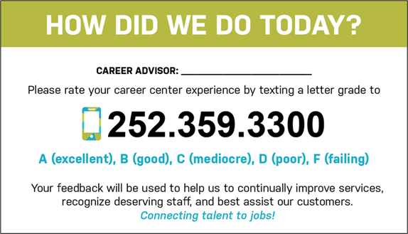

* 1. Customer Service Feedback Initiative invites customers to rate their career center experience through a letter grade, provides feedback, and enables management to quickly address issues related to D/F ratings
* CSFI Text Number is (252) 359-3300
* Ratings serves as basis for scores and are used to determine quarterly BRAVO Awards for Outstanding Career Advisor
* Customers grant permission for management follow up to poor rating, or high rating and related success story
* Initiative managed by Pat Harris at [pharris@mideastcom.org](mailto:pharris@mideastcom.org)

1. **Traitify** is a scientifically-based visual personality assessment designed to be completed in under two minutes.
   1. Traitify link is: <https://nencpathways.traitify.com/> Do not use the national Traitify URL.
   2. Career advisors and partners who have completed training are eligible to become Traitify Administrators by contacting Brandi Bragg at [brandi.bragg@nencpathways.org](mailto:brandi.bragg@nencpathways.org), or Pat Harris at [pharris@mideastcom.org](mailto:pharris@mideastcom.org)
   3. Traitify GADJ Lesson Plan can be found at: <http://riverseastwdb.org/wp-content/uploads/2020/03/Chpt1_LP1_Traitify.pdf>
   4. Traitify supplemental documents can be found by clicking on titles below:
      * [Traitify Self Discovery Guide](http://riverseastwdb.org/wp-content/uploads/2020/03/Traitify_SelfDiscoveryGuide.pdf)
      * [Beaufort Pathway2Success Worksheet](http://riverseastwdb.org/wp-content/uploads/2020/03/Beaufort_Pathway2Success_Worksheet_BCCC_012920.pdf)
      * [Bertie MCC Pathway2Success Worksheet](http://riverseastwdb.org/wp-content/uploads/2020/03/Bertie_Pathway2Success_Worksheet_MCC_012920.pdf)
      * [Bertie RCCC Pathway2Success Worksheet](http://riverseastwdb.org/wp-content/uploads/2020/03/Bertie_Pathway2Success_Worksheet_RCCC_012920.pdf)
      * [Hertford Pathway2Success Worksheet](http://riverseastwdb.org/wp-content/uploads/2020/03/Hertford_Pathway2Success_Worksheet_RCCC_012920.pdf)
      * [Martin Pathway2Success Worksheet](http://riverseastwdb.org/wp-content/uploads/2020/03/Martin_Pathway2Success_Worksheet_MCC_012920.pdf)
      * [Pitt Pathway2Success Worksheet](http://riverseastwdb.org/wp-content/uploads/2020/03/Pitt_Pathway2Success_Worksheet_PCC_012920.pdf)
2. **Virtual Job Shadow**
3. [Rivers East Staff Training with Nora Donovan](https://1drv.ms/v/s!AgJgZemtf236sjkhQu3sXnBge4RR)
4. [Walk through video of our groups and reports tools](https://helpcenter.virtualjobshadow.com/help/customer-workshop-groups-and-reports-514)
5. [Walk through video of our Career central + pop quizzes](https://helpcenter.virtualjobshadow.com/help/customer-workshop-career-central-479)
6. [Walk through of our FlexLessons tool](https://helpcenter.virtualjobshadow.com/help/customer-workshop-flexlessons)
7. [Step-by-step guide on how to create a report](https://helpcenter.virtualjobshadow.com/help/create-a-report)
8. [Life Skills Videos](https://helpcenter.virtualjobshadow.com/help/life-skills-videos)

**VirtualJobShadow.com Login Steps**

**PC**

1. Visit: <https://www.virtualjobshadow.com/>
2. Click the blue **Login** button in the upper right corner of the screen.



1. Start to type the name of your license in the **Search For Your License** bar until it appears in the drop-down menu. The license name will usually match the name of your school or organization.
2. Select the name of your license from the drop-down menu.
3. Login using your username and password.



1. If the name of your license is not displayed at the top of the login menu, click **Not your school or organization**? Repeat steps 3 and 4.



MOBILE

1. Visit: <https://www.virtualjobshadow.com/>
2. Click the white three-bar menu icon in the upper right corner of the screen.

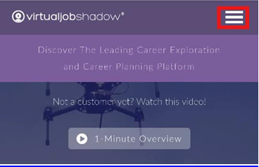

1. Select the blue **LOGIN** option

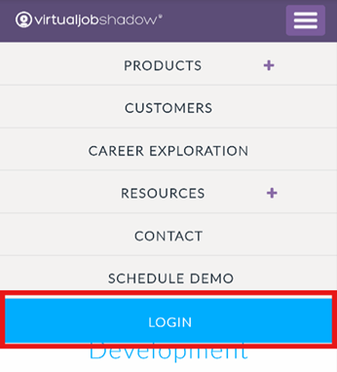

1. Start to type the name of your license in the **Search For Your License** bar until it appears in the drop-down menu. The license name will usually match the name of your school or organization.
2. Select the name of your license from the drop-down menu.
3. Login using your username and password.

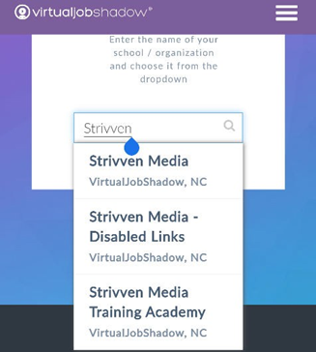

1. If the name of your license is not displayed at the top of the login menu, click Not your school or organization? Repeat steps 4 and 5.

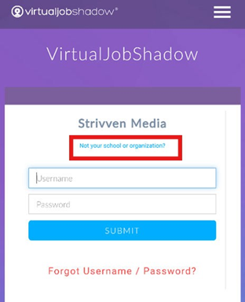

Email: [customerservice@virtualjobshadow.com](mailto:customerservice@virtualjobshadow.com)

