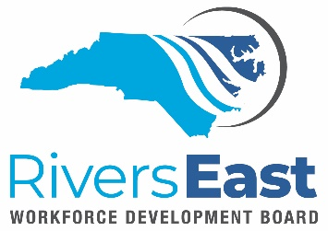

Technical Assistance (TA) Guide – Eligibility and Suitability

This TA Guide is to provide guidance on eligibility and suitability. This TA guide is not intended to be all inclusive but rather a guide to our service providers. It is the responsibility of the service provider to review all applicable policies.

It is a best practice to screen for suitability while screening for eligibility. You may find that while the individual is eligible for a program, they may not be suitable – at the time. Career Advisors can provide basic career services to anyone, without enrolling them in a WIOA program. This means you can assist with job search, resume writing, mock interviews, and multiple work readiness activities. Once the individual is suitable and ready, then you can enroll them in a WIOA program.

This allows you to get to know the individual and they have an opportunity to learn more about WIOA and the commitment they are required to make. This also allows you to give them assignments and see if they are committed to completing them and ready for enrollment.

Some suitability components to consider:
- Assessments: what are they telling you?
  - Traitify, TABE, My Next Move, etc.
- Did the individual attend activities? Appointments?
- Did they complete the assignments?
- Do they already have a credential? Or employable skill?
- What are their goals for the program?
  - If they just want supportive services – does another agency provide the service?
  - Are their goals achievable?
  - Is the training they want offered locally?
- Barriers – our programs are not designed to assist someone with many barriers to employment and/or training
- Do you need to consult with a partnering agency before finalizing enrollment? (VR, Domestic Violence shelter, etc.)
- Personal life – can they commit?

Remember our two main goals: training and employment when assessing an individual for suitability and enrollment.

For the youth participants, during enrollment, the barriers can become overwhelming. A best practice is to pick one – pick the barrier that you can easily document and when entering the enrollment case note, ensure that the barrier is clearly stated. Other barriers can and should be added on the Objective Assessment. Don’t make the enrollment process more difficult than it has to be when it comes to documentation.

Basic Adult Eligibility:
- 18 or over
- A US Citizen
- Be eligible for work
- Meet Selective Service requirements, if applicable

Basic DW Eligiblity:
- Long term unemployed
- Can’t return to previous career
- Laid off or have received a lay off notice

Basic Youth Eligibility:
- NC serves 16 to 24
- Barrier to employment (see eligibility guide for full list)

Applicable Policies

- Residency

