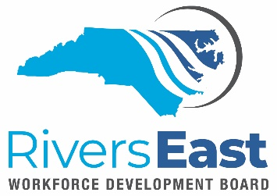

Technical Assistance (TA) Guide – Compliance Monitoring

This TA Guide is to provide the service provider with additional guidance when it comes to reviewing and monitoring participant files in NCWorks. This TA Guide is not meant to be all-inclusive. It is the responsibility of the service provider to review all applicable policies to ensure proper documentation and allowable expenditures.

A few suggestions to consider:

- Have you entered all appropriate case notes?
- Have you scanned all related supporting documentation?
- Have you added all appropriate activity codes?
- Does the following match?
  - Case notes should match IEP/ISS
  - IEP/ISS should match case notes
  - Documents scanned should match case notes and IEP/ISS
  - Activity codes should match service provided
    - Remember a “service” must be provided to record an activity

If it is not in NCWorks, we cannot verify that it happened and/or that policy was followed. Your case notes should tell the participant story as well as the services provided – think “who, what, when, where and how”.

The Local Area uses the WIOA Compliance Review Checklist (found on the website) when reviewing files for compliance. If you follow the checklist and ensure all items are checked “yes”, your participant files should be in compliance for both the local and state monitors. If you cannot check yes, please check with your program supervisor on how to correct the file.

The Local Area will conduct desktop reviews and provide feedback and best practices to correct issues as they are found. If you need additional technical assistance, please let us know.

Applicable policies:

- Invoice Processing and Reimbursement
- Financial Management
- Residency Requirements
- Oversight Monitoring

