Incumbent Worker Training Program
Grant Application

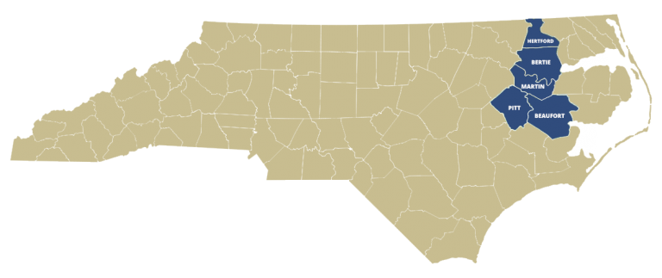

Program Year: July 1, 2022 to June 30, 2023

Rivers East Workforce Development Board
Mid-East Commission
1502 N Market St, Suite A
Washington, NC 27889
252-946-8043

Funded through the Workforce Innovation and Opportunity Act
An Equal Opportunity/Affirmative Action Employer/Program. Auxiliary aids and services available upon request to individuals with disabilities.
Rivers East Workforce Development Board
Mid-East Commission
Incumbent Worker Training Program Pre-Award and Grant Application

Note: Please answer all questions.

SECTION I. Business Information – business must be located in Beaufort, Bertie, Hertford, Martin, or Pitt County

A. Business Information
Business Name:

Street and Mailing Address:

City/State: |  |  | Zip: | County:
Business Contact Person: |  |  | Title:
Phone: | Ext: |  | Email address:
Website: |  |  | Years in business at training location:
Brief description of business product(s) and/or service(s):

Total number of paid employees at this location: |  | Total number of paid employees throughout NC: |  |  | NAICS Code:
Legal Structure of Business: ☐ Sole Proprietor ☐ Partnership ☐ Corporation ☐ LLC
Tax Status of Business: ☐ For-profit ☐ Not-for-profit
Federal ID Number: |  |  | NC Unemployment Number:

- Is your company a subsidiary of another company or affiliated with a parent company? ☐ Yes ☐ No

If “Yes”, please provide the following information about the corporate office/parent company, if different from above.

Parent Company Name:

Street and Mailing Address:

City/State: |  | Zip: |  | County:
Authorized Representative: |  |  | Title:
Phone: | Ext: |  | Email:

SECTION II. Training Plan
- Training Summary – Anticipated Project Start date:
Project Length: (can be no longer than 12 months from the date of the contract)
Total amount of funds being requested: $
- Training Components – below is a Training Component Template. The form can be replicated as many times as necessary to include all training components requested for funding. Note: “Component Cost charged to Grant” should capture all cost to be charged to the grant and should include but is not limited to: training materials, certifications costs, software, etc.

Training Component Template – Training Component #1
Training Topic/Course Title:
Course Description and Objectives:

Estimated Training Dates:
Number of Trainees: | Training Location:
Name of Training Provider:
Name of Trainer/Instructor: |  |  | Phone:
Address:
City: |  | State: |  | Zip:
E-Mail Address:
Qualifications of Trainer/Instructor to teach component (2-3 sentences):

NOTE: This template is to be replicated for each Training Component. Duplicate information in additional components that appears in a prior component may be noted as “Same as Component #____” in the appropriate subsection.

- Is this a collaborative grant? ☐ Yes ☐ No If yes, please complete the information below:

Company Name:

Street/Mailing Address:

City/State: |  |  | Zip: |  | County:
Authorized Representative: |  |  |  | Title:
Phone: | Ext: |  |  | Fax:
E-Mail Address: |  | Company Website:

SECTION III. Budget
- The applicant is encouraged to apply only for funds needed and not to exceed $10,000.00. The project budget should clearly support and relate to the training plan and itemize how the award is used. The amount under the “Grant Funds Requested” column below should equal the total of the amounts shown under “Component Cost Charged to Grant” for all Training Components listed in Section III. All proposed expenses must be allowable, reasonable and necessary (see attachment: Reimbursable and Non-Reimbursable Training Costs). Please provide the required information on the attached budget form.
The applicant is encouraged to place a monetary value on the contributions that will be made to this training request, if funded. These contributions may be in-kind, cash, etc. A column is provided for this information.
See attached Excel budget spreadsheet
- Business non-federal share (indicate choose only one)
  - My business has less than 50 employees, a 10% non-federal share is required ☐
  - My business has between 50 and 100 employees, a 25% non-federal share is required ☐
  - My business has more than 100 employees, a 50% non-federal share is required ☐

Please complete the table below to determine non-federal share:

Total Wages: $ | Total Meals/Travel: $ | Facility Fee: $
Other (please specify):

Total non-federal share: $

SECTION IV: Training Abstract
Please provide all of the following information on a separate document.

- Background information on the business;
- Overview of the training and information to support the request and need for training;
- Description of how the requested training will address the identified skills gaps, improve employee retention, impact business stability, and increase the competitiveness of the employee and business; and
- Reason for requesting financial assistance to conduct the training.

SECTION V. Authorization and Certification
As authorized representative for the business submitting this application, I hereby certify that:
- I have read the Incumbent Worker Training Policy and Program.
- The business meets the requirements of the policy in regard to business and employee eligibility and is eligible to submit this application.
- The information contained in this application is true and accurate.
- I am aware that any false information, intentional omissions, or misrepresentations may result in rejection of the application and possible disqualification for future funding.
- The business agrees to adhere to all reporting requirements requested by the Rivers East Workforce Development Board upon notification of award.
- The business agrees to provide all requested data elements as required for federal reporting.
- The business confirms and verifies that all employees’ verification documents are current (I-9s) and accurate and are available upon request by the Rivers East Workforce Development Board.
- The business agrees to resubmit this application if the Rivers East Workforce Development Board requests within the designated timeframe.
- The requested training expenses is in accordance with the reimbursable requirements.
- Trainee applications for all employees seeking training will be provided when requested, with all applicable information for federal reporting purposes.

Further, this business shall not discriminate against any employee, applicant for employment, applicant or Workforce Innovation and Opportunity Act (WIOA) participant, subcontractor or potential beneficiaries of employment and training programs or projects because of race, color, disability, religion, age, sex, national origin, political affiliation or belief.

Printed Name Title

Signature Date

ATTACHMENT A
ATTESTATION FORM

Rivers East Workforce Development Board Incumbent Worker Training Grant
This form must be completed and signed by the Owner, President, CEO, or highest ranking local official of each business in North Carolina included in the Incumbent Worker Training Grant Application.

Please review and select the appropriate lay-off aversion criteria that apply. More than one may be chosen. Space will expand as text is entered.

- The company is phasing out a function which will lead to layoffs unless the workers can be retrained to perform new functions.
Explanation:

- A worker’s job has changing skill requirements as a result of external economic or market forces, significant changes in technology, rapidly changing industry or occupational requirements or emergence of new product.
Explanation:

- The changing skill requirements are outside the normal skill growth and upkeep that would be provided by the employer.
Explanation:

I hereby certify that the information provided herein is true and accurate and that any false information, intentional omissions, or misrepresentations will disqualify the application for the Incumbent Worker Training Program.

Printed Name Title

Signature Date

