

WORKFORCE INNOVATION AND OPPORTUNITY ACT

WORK EXPERIENCE PROGRAM HANDBOOK FOR PARTICIPANTS AND SUPERVISORS

ADULT, DISLOCATED WORKER AND YOUTH

Service Provider:

Address:

Telephone:

Equal Opportunity Employer/Program.

Auxiliary aids and services available upon request to individuals with disabilities.
PARTICIPANT AND SUPERVISOR WORKSITE HANDBOOK

WORK EXPERIENCE COMPONENT

WORKFORCE INNOVATION AND OPPORTUNITY ACT

Welcome to the Rivers East Workforce Development Board’s Work Experience Program. The work experience program is designed to assist our participants with employment opportunities, which will give them valuable, work experience, income and make them more self-sufficient.

The purpose of this Handbook is to acquaint you with the requirements of the work experience program. Becoming familiar with the contents of this handbook and keeping it accessible during the program will help you, should questions arise.

The Rivers East work experience component is operated by , under a plan developed by the Rivers East Workforce Investment Consortium (Mid-East Commission/Administrative Entity).

You should read this handbook thoroughly during your orientation and become familiar with its contents. If you have any questions, feel free to ask your Career Advisor.

OBJECTIVES

The purpose of the work experience program is to provide participants with short-term work to help them develop good work habits and basic work skills. Through experience gained in a realistic work situation, participants will not only develop new skills and explore career choices, but will learn to compete successfully in the labor market. Participants in the program may have never worked before or may have not worked for an extended period of time.

ORIENTATION

Each participant and supervisor will receive orientation prior to reporting to the Rivers East work experience program work site. The orientation provided by WIOA Career Advisor includes an explanation of the code of conduct, the role of the Career Advisor, expectations of the worksite supervisor, infractions that will bring about termination from the work experience program and other general program information.
CONTACTS

Beaufort County  Beaufort County NCWorks Career Center  1502 N. Market Street  Washington, NC 27889  (252) 940-0900 | Martin County  Campus of Martin Community College  1161 Kehukee Park Road, Building 1  Williamston, NC 27982  (252) 792-7816
Bertie County  Martin Community College – Bertie Campus  409 Granville Street  Windsor, NC  (252) 794-4861 x125 | Hertford County  Roanoke-Chowan Community College Campus  109 Community College Road  Jernigan Building B  Ahoskie, NC  252-862-1257
Pitt County
Pitt County NCWorks Career Center
3101 Bismarck Street
Greenville, NC 27834
(252) 355-9067

SUPERVISION

As a worksite supervisor, your contribution is critical to the success of the program. Please do not hesitate to direct questions to the WIOA Career Advisor. No participant will be allowed to begin work without prior verification by the WIOA Career Advisor.

Orientation by the worksite is regarded as a compensable activity from the participant’s point of view and the time should be reported on the first timesheet. The following are important areas that should be covered in a short orientation session once the participant(s) report to work:

- welcome participant(s);
- explain the rules and let them know that is expected of them;
- discuss safety rules and explain the need for safe working habits;
- encourage questions; and
- show participants where rules and regulations are posted.

Participants may be terminated or suspended from work experience for any of the following:

- failure to be on time;
- unexcused absences;
- failure to do the job;
- dishonesty;
- disrespect;
- falsification of information on timesheets or other forms;
- endangering the lives of co-workers or themselves;
- stealing or receiving stolen property while on the job;
- using, selling, or receiving any form of narcotics, drugs, or other substances;
- alcoholic beverages on the job;
- reporting to work under the influence of alcohol, drugs or other substances; and/or
- immoral behavior during work hours.

Note: Be sure to review work hours and let participants know what is expected with regard to lunch breaks and other normal break periods. WIOA participants should be provided the same lunch and break schedule as other employees.

PAYROLL PROCESS

Participants’ checks should be mailed/direct deposited or delivered as set forth in the timesheet/payroll schedule provided by the WIOA Service Provider. Rivers East work experience participants will be paid at a specified rate and paid only for the hours worked. Total weekly hours worked cannot exceed 29 hours. This includes a total of work hours only. Participants will not be paid for holidays or other absences. It is the responsibility of the participant to notify their Career Advisor of any address changes.

TIMESHEETS

The Career Advisor will deliver participant timesheets to the worksite supervisor with the information on the upper portion completed. The timesheet is the official record determining the pay for the participant. It is your responsibility to ensure that the participants at the worksite correctly report all time worked. Participants must sign the timesheet in black or blue ink at the end of each day and at the end of each pay period. Any change on a timesheet must be marked through and initialed by the participant and supervisor. Do not allow participants to sign out for the day until the end of the day. You are not to pre-sign timesheets. Under no circumstances should whiteout be used on timesheets. Messy timesheets or those with obvious whiteout will not be considered for reimbursement. It is the responsibility of the Career Advisor and the Program Supervisor to review the timesheet thoroughly before approving for payment.

Each participant will enter the actual hours worked, but the supervisor must verify hours reported before the supervisor signs the form. In the event the participant hours needs to be rounded, hours should be rounded up to the nearest “quarter” hour. For example, if the participant records 5.20 hours; that can be rounded to 5.25 hours. If the participant records 5.60 hours; that can be rounded to 5.75 hours.

Please make sure the timesheet is complete, signed, and ready to be picked up by the WIOA Career Advisor. If the timesheet is completed incorrectly or is not submitted as scheduled, the participant will not receive his/her check on time. You will be given a payroll schedule which outlines the beginning and ending dates of pay periods, the date the timesheets will be picked up for processing, and the date checks will be mailed. Keep this pay schedule in a convenient location.

PREVAILING WAGE

Individuals participating in a work experience opportunity must be compensated at the same rates, including periodic increases, as participants, or employees who are similarly situated in similar occupations by the same employer and who have similar training, experience, and skills. The rates may not be lower than the higher of the federal or state minimum wage. Career Advisors must follow the Prevailing Wage Policy when working with the employer to establish this wage.

TRANSFER

A participant will be considered for transfer whenever there is a conflict with the job site supervisor, co-workers, and/or other participants that cannot be resolved. However, every effort will be made to resolve the conflict without necessitating such action.

EVALUATION

Participants will be evaluated periodically during the program. The Local Area requires at a minimum, a mid-point and final evaluation. Work skills, from the Work Plan, will be measured based on demonstrated performance at the worksite. As a Worksite Supervisor, you will be required to complete an evaluation on each participant under the work experience program. The Evaluation should be reviewed and discussed with the participant and Career Advisor. The Form should be signed by the Supervisor, Participant, and the Career Advisor. A sample form is on page 8.

SAFETY RULES/REGULATIONS

It is the responsibility of each worksite agency/organization to discuss safety rules and regulations with each participant. It is the responsibility of the agency to ensure OSHA compliance. Each participant must be made aware of the proper safety procedures in case of a fire, injury, or other emergencies

WORKER'S COMPENSATION

If an accident occurs on the job, Worker’s Compensation Insurance provided by the WIOA Service Provider covers the participant. The person noted on the Rivers East WIOA Emergency Contact Form should be contacted immediately as well as the WIOA Career Advisor. Please provide the WIOA Career Advisor all the details regarding the accident as well as if the participant was transported to a local hospital.

HATCH ACT/POLITICAL ACTIVITY

Persons in a federally funded grant-aid program are covered under the Hatch Act. Participants will sign a Hatch Act Form during their orientation stating they will not participate in any political activities while enrolled in the WIOA Youth Program.

RELIGIOUS ACTIVITY

No participants in this federally funded program may be involved in religious instruction or activities while on the job.

NEPOTISM

Participants cannot report directly to family members while enrolled and participating in a work experience.

WORKSITE AGREEMENT

The Rivers East Workforce Development Board Worksite Agreement explains the requirements and limitations for the worksite and the WIOA Service Provider. The job description must be reviewed to inform the participant of assigned job duties and responsibilities. All worksites agree to:

- Comply with the Fair Standard Act, current child labor laws and appropriate North Carolina State and Federal Labor Laws/standards including ADA and OSHA regulations.
- Have a contingency plan for inclement weather when the regular Worksite is designated as out-of-doors.
- Provide adequate full-time supervision of each WIOA participant by qualified supervisors. When the regular Worksite Supervisor is unavailable, an alternate supervisor will be designated.
- Provide sufficient equipment and/or materials provided to carry out work assignments.
- Provide sufficient, meaningful work to keep WIOA participants fully occupied during work hours.
- Provide a safe and sanitary work environment.
- Oversee the maintenance and certify as accurate, records of participant’s time and attendance.
- Notify the WIOA Service Provider within 24 hours of any accidents, special situations or unusual occurrences.
- Evaluate each participant as agreed upon and required by the WIOA Career Advisor.
- Provide participants with appropriate breaks and lunch hour.

EQUAL OPPORTUNITY

Participants are provided information on their rights under Equal Opportunity at enrollment.

FORMS INCLUDED with HANDBOOK

- Timesheet and Evaluation Form, all participants utilize the same forms
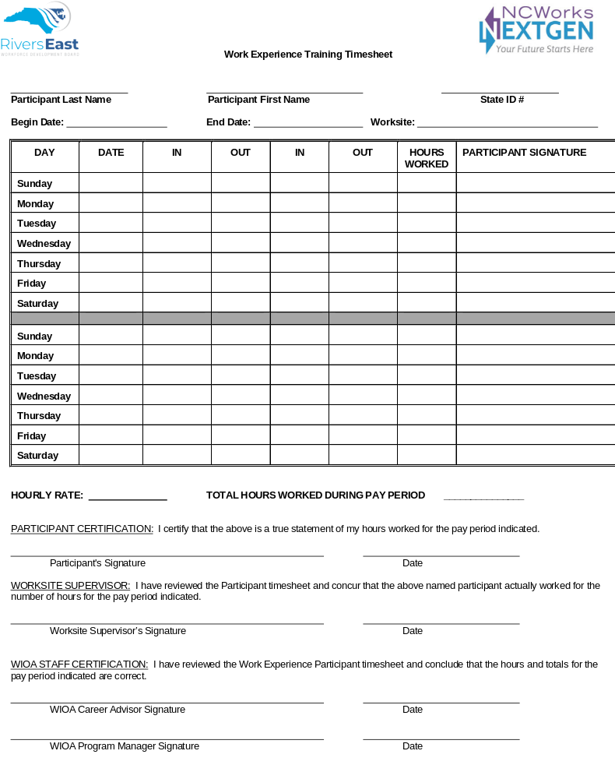

Rivers East Workforce Development Board

Work Experience (WEX) Participant Evaluation

Participant Name: Supervisor Name:

Section 1: Evaluation
JOB TASKS FROM PARTICIPANT’S WORK PLAN | MIDPOINT EVALUATION OF TASKS | MIDPOINT  EVALUATION  DATE | FINAL  EVALUATION OF TASKS | FINAL  EVALUATION  DATE
 | Mastered objective  Satisfactory progress  Unsatisfactory progress |  | Mastered objective  Satisfactory progress  Unsatisfactory progress
 | Mastered objective  Satisfactory progress  Unsatisfactory progress |  | Mastered objective  Satisfactory progress  Unsatisfactory progress
 | Mastered objective  Satisfactory progress  Unsatisfactory progress |  | Mastered objective  Satisfactory progress  Unsatisfactory progress
 | Mastered objective  Satisfactory progress  Unsatisfactory progress |  | Mastered objective  Satisfactory progress  Unsatisfactory progress
 | Mastered objective  Satisfactory progress  Unsatisfactory progress |  | Mastered objective  Satisfactory progress  Unsatisfactory progress
 | Mastered objective  Satisfactory progress  Unsatisfactory progress |  | Mastered objective  Satisfactory progress  Unsatisfactory progress
 | Mastered objective  Satisfactory progress  Unsatisfactory progress |  | Mastered objective  Satisfactory progress  Unsatisfactory progress

Section 2: Authorized Signatures

Midpoint Evaluation Final Evaluation
I hereby certify that the above information is accurate. |  |  | I hereby certify that the above information is accurate.
TRAINEE SIGNATURE: | DATE: |  | TRAINEE SIGNATURE: | DATE:
WORKSITE SUPERVISOR SIGNATURE: | DATE: |  | WORKSITE SUPERVISOR SIGNATURE: | DATE:
WIOA CAREER ADVISOR SIGNATURE: | DATE: |  | WIOA CAREER ADVISOR SIGNATURE: | DATE:
PROGRAM MANAGER SIGNATURE: | DATE: |  | PROGRAM MANAGER SIGNATURE: | DATE:

Section 3: Comments (please explain any unsatisfactory evaluation items)

Participant and Supervisor Orientation Signature Page

I attest that I have attended a WIOA Work Experience Supervisor Orientation and have received information on the policies, procedures, forms and requirements of the WIOA Work Experience component. I have received a copy of the Participant and Supervisor Handbook and will retain a copy of my reference.

Lead Supervisor Signature, Job Title and Date

Alternate Supervisor Signature, Job Title and Date

I attest that I have attended a WIOA Work Experience Participant Orientation and have received information on the policies, procedures, forms and requirements of the WIOA Work Experience component. I have received a copy of the Participant and Supervisor Handbook and will retain a copy of my reference.

Participant Signature and Date

I attest that I provided both the participant and the supervisor with a WIOA Work Experience Orientation and have reviewed information on the policies, procedures, forms and requirements of the WIOA Work Experience component. I have provided each a copy of the Participant and Supervisor Handbook and will maintain the original signed copy.

WIOA Career Advisor Signature and Date

Worksite Name:
Dates of Training:
Training Location:

Signature page MUST be scanned into NCWorks Online.

