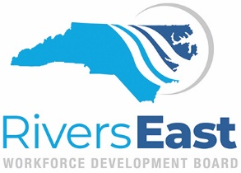

AGENDA
Wednesday, May 10, 2023
3:00 PM
Hybrid- NCTeleCenter or Via ZOOM

The purpose of the Rivers East Workforce Development Board is to provide regional leadership, guidance and support to meet the changing needs of our communities through strategic innovation and collaboration.

3:00 Call to Order Robert Williams, Chair
Determination of a Quorum

3:10 Consent Agenda* Robert Williams, Chair
Approval of March 8, 2023 Meeting Minutes
Operator Performance Reports

3:15 Committee Reports-
Youth/NEXTGEN Committee Report* Trey Goodson, Committee Chair
Work Experience Policy Revision
PY’ 23 Procurement

NCWorks Committee Report* Vivian Saunders, Committee Chair
IWT Grant Request
Funding Recommendations
PY’ 23 Procurement
Work Experience Policy Revision

Inclusion Committee Report* Jenny Brown, Committee Chair
DEI Training for Board Members

3:45 Local Area Plan Update* Jennie Bowen, Director

3:55 ETPL Update* Kim Laws, Program Specialist A/DW/OS

4:05 Nominating Committee* Wendell Hall, Committee Chair

4:15 Strategic Initiatives Updates & Activities Ashlan Crouch, Strategic Initiatives Coordinator
4:20 Other Business
Board Retreat Robert Williams, Chair
Board Meeting Schedule/Method for PY23 Robert Williams, Chair
NC Allocations for PY23 Jennie Bowen, Director

4:30 Adjourn
Next Meeting: Wednesday, September 13, 2023 3:00 p.m.

