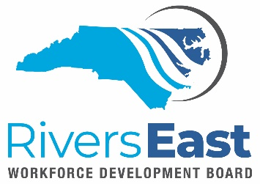

Technical Assistance (TA) Guide – Youth Incentives

This TA Guide is to provide guidance on paying incentives to active youth participants. This TA guide is not intended to be all inclusive but rather a guide to our service providers. It is the responsibility of the service provider to review all applicable policies.

Incentives are intended to assist the Career Advisor in ‘motivating’ the participant to be engaged and actively participate in the program. Incentives can be a great motivator if used in conjunction with work readiness activities.

Each participant is required to sign the Incentive Contract during enrollment, which must be scanned into NCWorks. While not required, a best practice is to provide the youth with a list of incentives they can earn.

Eligible incentives:

- $100 for high school diploma
- $100 for the National Career Readiness Certificate
- $100 for a MSG, this incentive must match training activity code
- $100 for unsubsidized employment
- Work readiness incentives: ($20 each, limitations apply)
- Essential Skills through WorkKeys
- HRD classes at a local community college
- Attending career/job fairs
- Completing GADJ assignments
- Completing activities on NC Careers.org
- Completing a financial literacy class
- Completing other activities such as interview workshops, resume writing workshops, work ethic or soft skills training, time management, etc.

Not eligible:
- Hours spent in GED classes
- Can’t earn an incentive for the same activity under a different category

If service providers offer an activity that is not listed in policy and they would like to pay an incentive, prior approval from the Local Area is required. The Youth Program Manager would need to forward all the details, in writing, to the Workforce Development Director.

All incentives must be clearly case noted and documented on the IEP/ISS and the OA. In addition, supporting documentation along with the Incentive Payment Form must be scanned into NCWorks. Career Advisors will record a CSS activity ensuring the case note matches the case note added in NCWorks.

When offering work readiness activities, a best practice is to offer them in person and/or in cohorts. This ensures participants are actively engaged and can help hold each other accountable.

Applicable policies:

- Supportive Services
- Individual Training Account
- Youth Incentive
- NCWorks Service Activity Codes, Case Notes and Exit Dates
- Program Exit, Follow-up and ReEnrollment

