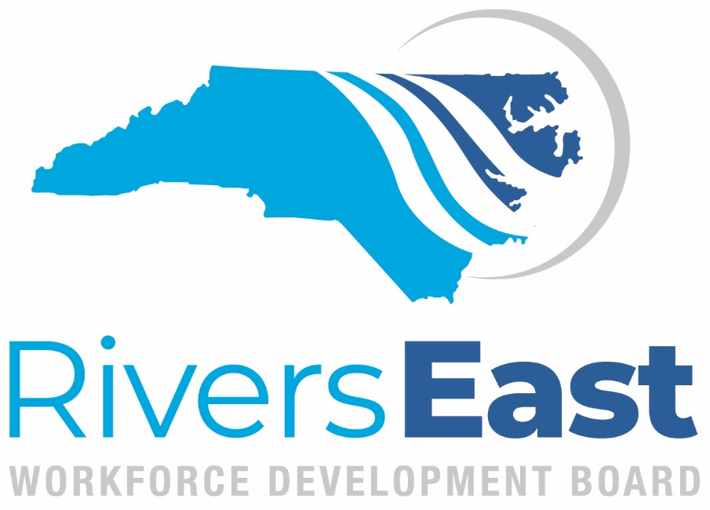
2024-2025 Meeting Schedule

September 11, 2024
Martin Community College, Williamston
November 13, 2024
Nutrien, Aurora
January 8, 2025
March 12, 2025
May 14, 2025

Board meetings are held the 2nd Wednesday of every other month, with the exception of July, at 3:00 p.m.
Meetings locations will be updated once secured and will rotate around the region. A hybrid/virtual option will be available as well.

