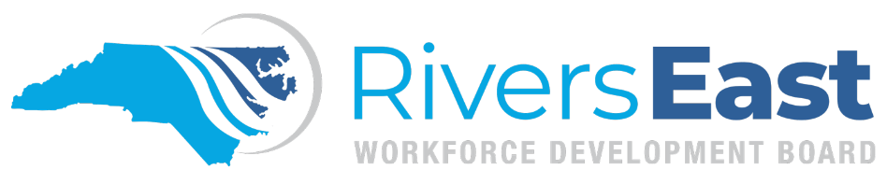

Operational Guidance 02-2024 – Assessments

This guide is to provide guidance on assessments. While comprehensive, please recognize that it may not encompass every aspect. It remains the responsibility of the program operator and staff to thoroughly review all relevant policies to ensure proper documentation and allowable expenditures.

During the enrollment process, individuals must be engaged in assessment. Assessment is a holistic, ongoing process and should not be viewed as a one-time event. Assessments provide valuable information to decipher the best way to guide the individual towards an employment goal. The results of assessments must be explained to an individual and analyzed to provide guidance in determining action steps and services to be included in the Individual Employment Plan (IEP)/Individual Service Strategy (ISS).

From the information compiled during assessments, appropriate One-Stop partners and services should be identified to provide direct linkage to services in the One-Stop System and active resource coordination with other One-Stop Partners.

INITIAL ASSESSMENT
The initial assessment is part of the Wagner-Peyser program. The Objective Assessment can be done prior to enrollment in WIOA. The initial assessment is completed through conversations to determine appropriate One-Stop services and coordinated referrals with partner agencies to assist an individual in achieving their goals. The Initial Assessment is part of the overall intake process and includes informal verbal discussion, the initial determination of the following:

- Identification of strengths
- Identification of workplace skills
- Career interests
- Work values
- Identification of prior work history
- Family situation
- Services needed
- Basic skills

Assessments to determine academic readiness for training, licensure, credential attainment or any goal requiring basic academic skills should be administered or used prior to enrollment in Title 1 programs. These assessments may include:

- Report Card of most recent school term
- College Transcript of most recent term
- TABE Reading, Math and/or Language assessment (given no earlier than 6 months prior to enrollment and/or the within the last 90 days of the previous program year)
- CASAS Reading and/or Math
- NCRC/Work Keys
- College program entrance exam results
- TEAs Test results

Assessments must show academic readiness for successfully completing occupational training classes or passing licensure exams. EFLs as measured by CASAS or TABE should be no lower than 3 for enrollment in training. GPAs should be no lower than 2.0. College entry exam scores should not indicate a need for remedial (transition) classes. NCRC must be at least bronze level.

Academic Assessments are not required if occupational training and/or licensure exams are not a part of the Objective Assessment and IEP/ISS. Formal academic assessment results within the last six months, provided by the participant or a partner agency, are acceptable to use.

OBJECTIVE ASSESSMENT
The Objective Assessment is part of the WIOA Title I program and includes a further analysis of the Initial Assessment results and formal testing as it applies to the ISS/IEP. The Objective Assessment can also be completed prior to Title I enrollment. This can include the following:

- Basic skills
- ACCUPLACER®
- WorkKeys Curriculum Placement Quiz. WorkKeys Assessments
- TABE®
- Report Card
- College transcript
- NCRC
  - Identification of strengths
  - Identification of workplace skills
  - Career interests
  - Work values
  - Identification of prior work history
  - Family situation
  - Services sought

Additional Suggested Assessments:
  - Digital Literacy
  - Financial situation

The results from an Objective Assessment assist in the development of a WIOA Title I participant’s ISS/IEP. An Objective Assessment is not required for Wagner-Peyser participants. An objective assessment must be completed during the WIOA Title I enrollment process. Follow all applicable guidance for an objective assessment as outlined for Title I Youth, Adult, and Dislocated Worker.

REASONABLE ACCOMMODATIONS
Reasonable accommodations may be made according to the assessment publisher guidelines. If a particular situation limits an individual’s ability to complete a formal assessment, this should be documented in case notes.

Applicable Policies, TEGLs, and other Documents:
https://www.dol.gov/sites/dolgov/files/ETA/advisories/TEGL/2022/TEGL%2009-22/TEGL%2009-22.pdf
https://www.dol.gov/sites/dolgov/files/ETA/advisories/TEGL/2022/TEGL%2021-22/TEGL%2021-22.pdf
https://www.dol.gov/sites/dolgov/files/ETA/advisories/TEGL/2017/TEGL_19-16.pdf
https://youth.workforcegps.org/resources/2021/02/09/11/50/Strategies-and-Considerations-A-Brief-on-Youth-Assessments
WIOA sec. 134(c)(2)(A)(xii)(II); WIOA § 680.170
https://www.commerce.nc.gov/guidance-case-notes-and-exit-dates-ncworks-online-0/open
http://riverseastwdb.org/wp-content/uploads/2023/06/2021-09-ss.pdf (Supportive Services policy)
https://www.ncworks.gov/admin/gsipub/htmlarea/uploads/Staff%20Guide_06_Programs_WIOA.pdf
https://www.dol.gov/agencies/eta/performance/performance-indicators

