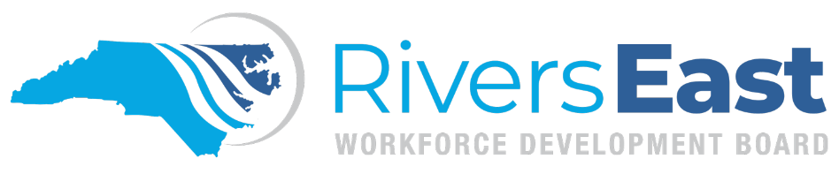

Operational Guidance 03-2024 – Objective Assessment and IEP/ISS

This guide is to provide guidance on completing the Objective Assessment for all participants, and the Individual Employment Plan (IEP) for Adult/Dislocated Workers or the Individual Service Strategy (ISS) for Youth participants. While comprehensive, please recognize that it may not encompass every aspect. It remains the responsibility of the program operator and staff to thoroughly review all relevant policies to ensure proper documentation and allowable expenditures.

The Objective Assessment is completed on the Plan tab and does not have to be signed and scanned into NCWorks. However, it must be kept updated and reviewed on a regular basis. At minimum, the OA should include:

- Assessments
- Barriers
- Services Sought: this is required by State Supportive Services policy and should reflect all services provided to the participant, including any anticipated incentives for youth.
- Career pathways to consider

Once the Objective Assessment has been created in the Plan tab, the “Objective Assessment” activity must be recorded using the same date as participation—code 203 for Adults/Dislocated Workers (A/DW) and code 412 for Youth.

The Objective Assessment guides the process to complete the IEP/ISS. A strong Objective Assessment will assist in creating a strong IEP/ISS.

Each IEP/ISS should be individualized and developed with the participant based on their status and circumstances. The IEP should be created on the same day as WIOA participation. The IEP/ISS must have the following components:

- At least one training goal with supporting objectives (two to three objectives per goal)
- At least one employment goal with supporting objectives (two to three objectives per goal)
- Supportive Services as objectives, when applicable, for each related goal. This objective should list, in detail, the supportive services the participant “may” need as the work to obtain their training and/or employment goal. For youth participants, anticipated incentives should also be included.
- If the individual is in traditional high school or is a high school drop-out, a schooling goal and related objectives are required.

Listed below are recommendations for consideration on what to include in the supportive services objectives:

- What supportive services will be needed to meet their program goals?
- What assessments have they taken or may need to take as it relates to their goal?
- What barriers to employment and/or training do they have and how do you plan to address them during their enrollment in the program? Childcare, transportation, tuition, books, supplies, etc.
- Potential needs to complete WEX/OJT: tools, uniforms, etc.

When writing goals use the SMART method:
- Specific
- Measurable
- Attainable
- Relevant and Realistic
- Time-Driven

Goals and objectives must be specific. Specific career paths must be included in the training and employment goals. If a specific career path is unknown, several should be selected based on the Objective Assessment and interest assessments, and objectives for career exploration strategies should be included for narrowing down the goal to one pathway.

Potential MSGs should be included in the IEP as objectives to the training goal. Potential MSGs may include certifications that will be received as a part of Occupational Skills Training (BLS, OSHA, CPR, etc.).

Once the IEP has been created in the Plan tab, both the participant and the Career Advisor should sign it. The signed IEP should then be uploaded to the Documents tab. Additionally, the “Creation of IEP/ISS” activity must be recorded using the same date as participation—code 205 for Adults/Dislocated Workers (A/DW) and code 413 for Youth.

The IEP/ISS must be updated jointly with the participant every 90 days. The updated IEP/ISS must be signed by the participant and the Career Advisor, added to the Documents tab labeled by update, and the associated activity recorded (20A for A/DW and 41A for youth). The activity should be open and closed on the same day and a linked case note recorded that summarizes the changes made to the plan. For youth, a staff assisted activity must also be recorded on the day the IEP is updated.

For youth participants – supportive services can be paid during the 12-month follow-up period, provided the supportive services are listed on the Objective Assessment and IEP/ISS prior to exit. For this reason, it is imperative that Career Advisors ensure both are updated to include any foreseeable needs during the exit process.

Applicable Policies, TEGLs, and other Documents:
https://www.dol.gov/sites/dolgov/files/ETA/advisories/TEGL/2022/TEGL%2009-22/TEGL%2009-22.pdf
https://www.dol.gov/sites/dolgov/files/ETA/advisories/TEGL/2022/TEGL%2021-22/TEGL%2021-22.pdf
https://www.dol.gov/sites/dolgov/files/ETA/advisories/TEGL/2017/TEGL_19-16.pdf
https://youth.workforcegps.org/resources/2021/02/09/11/50/Strategies-and-Considerations-A-Brief-on-Youth-Assessments
WIOA sec. 134(c)(2)(A)(xii)(II); WIOA § 680.170
https://www.commerce.nc.gov/guidance-case-notes-and-exit-dates-ncworks-online-0/open
http://riverseastwdb.org/wp-content/uploads/2023/06/2021-09-ss.pdf (Supportive Services policy)

