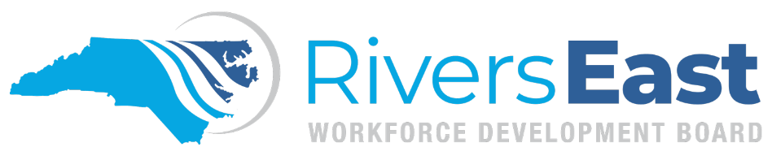

Operational Guidance 05-2024 – Supportive Services

This guide is to provide guidance on and examples of supportive services. While comprehensive, please recognize that it may not encompass every aspect. It remains the responsibility of the program operator and staff to thoroughly review all relevant policies to ensure proper documentation and allowable expenditures.

Supportive services should be “individualized” and utilized based on the status and circumstances of the individual participant and the demonstration of financial need. All supportive services should be tied to training and a training activity code should be open in NCWorks Online. Funds should be used in a manner that avoids duplication of services.

The need for supportive services along with confirmation of no other resources being available must be documented in the IEP/ISS, Objective Assessment, and in NCWorks case notes. The appropriate CSS activity code should also be added. Supportive service activities must be paired with a staff-assisted activity to ensure participants receive financial assistance in conjunction with meaningful career advising.

Examples of supportive services:

- Transportation
  - Paid to and from the participant’s home address and the training facility (one round trip per day); class schedule must be scanned into NCWorks. If paying the participant to attend clinical training, the clinical schedule must be scanned into NCWorks. Max is $168 per week or 300 miles.
- Childcare assistance
  - May be provided for children under six (6) years of age and for school aged children after school hours. Max is $140 per week for first child, and max of $85 per week for second child.
- Tools, equipment, uniforms, and other related educational items (including graduation caps and gowns)
  - Must be related to WIOA sponsored training and/or paid work experience.
  - The participant must provide a “needs” list from the training provider and/or employer stating exact items that need purchasing. The Local Area must approve any purchase above $500 (exception is textbooks).
  - For those that need online tools purchased for GED, if the participant’s EFL is 3 or lower, he/she is required to enroll in an approved seated training and make satisfactory progress before online tools can be purchased. If the participant’s EFL is 4 or higher, online tools can be purchased once during the program year.
- Incentives (youth only)
  - Must be included in ISS prior to payment

Additional notes:

- Any “other” supportive services must have prior approval from the Local Area
- To provide a supportive service to a youth participant (in follow up), the supportive service(s) must be listed on the IEP/ISS, OA and in case notes prior to exit.

Applicable Policies, TEGLs, and other Documents:
http://riverseastwdb.org/wp-content/uploads/2023/06/2021-09-ss.pdf (Supportive Services)
https://www.dol.gov/sites/dolgov/files/ETA/advisories/TEGL/2022/TEGL%2021-22/TEGL%2021-22.pdf
https://www.dol.gov/sites/dolgov/files/ETA/advisories/TEGL/2022/TEGL%2009-22/TEGL%2009-22.pdf
https://www.dol.gov/sites/dolgov/files/ETA/advisories/TEGL/2020/TEGL_8-19.pdf
https://www.dol.gov/sites/dolgov/files/ETA/advisories/TEGL/2017/TEGL_19-16.pdf
https://www.commerce.nc.gov/workforce-innovation-and-opportunity-act-wioa-tegl-adult-and-dw/open

:

