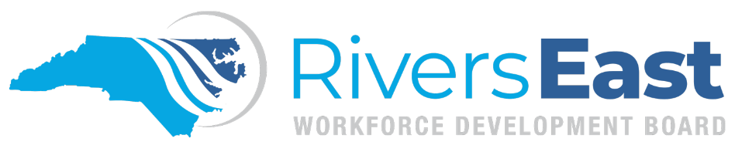

Operational Guidance 10-2024 – Compliance Monitoring

This guide is to provide guidance on reviewing and monitoring participant files in NCWorks Online. While comprehensive, please recognize that it may not encompass every aspect. It remains the responsibility of the program operator and staff to thoroughly review all relevant policies to ensure proper documentation and allowable expenditures.

The best practice to ensure accuracy is to frequently review your files. While reviewing your files, answer the questions below.

- Does the information entered in the WIOA application also match the case notes and the documentation uploaded?
- Is the path of eligibility clearly laid out in the case note of the initial activity? Remember, you only need one path of eligibility. Choose the path of least resistance. Include all other barriers in the Objective Assessment.
- Was the WIOA application signed on the same day as participation?
- Were the OA and IEP/ISS completed and activities recorded on the same day as participation? Is the Objective Assessment detailed? Does the IEP/ISS include at least one training goal, one employment goal, and two objectives for each goal? Were the goals and objectives established using the S.M.A.R.T. method? Do both the OA and IEP/ISS include supportive services, if needed? Do the case notes within the activities for completing the OA and IEP/ISS summarize what was discussed and documented?
- Have all Intake and Enrollment documents and forms been completed and uploaded?
- Is a service being provided and an activity recorded at least every 90 days? Is contact being made and a case note recorded at least every 30 days?
- Has an activity been recorded for every service that has been provided? Have the activities been closed properly? Do the dates entered match the verification uploaded? Do all activities have a case note on the closure screen that details the service provided as it relates to that activity?
- If the participant is attending training, has the Training Justification been completed? Are all transcripts uploaded? Have you recorded MSGs? If they’ve completed training, have you recorded the credential?
- Are case notes factual and specific? Does each case note also include the date in the text box?
- Are all documents named and tagged using the Scanned Document Guide?
- Have you redacted all PII that is not being used for verification?
- Are there duplicate documents that need to be deleted? Are all documents legible?
- Is follow-up being conducted and recorded?

NCWorks Online allows users to schedule reports and alerts. Provider staff should take advantage of this feature to help stay on top of their files and avoid necessary corrections.

The Local Area will conduct desktop reviews and provide feedback and best practices to correct issues as they are found. Official monitoring will occur at least once per program year.

Applicable Policies, TEGLs, and other Documents:
http://riverseastwdb.org/wp-content/uploads/2022/07/Issuance-2021-35-Oversight-Monitoring-Policy.pdf
http://riverseastwdb.org/forms/#1626378560259-78884edd-229c (scanned document guide)
http://riverseastwdb.org/forms/#1626378560259-78884edd-229c (correction request form)
http://riverseastwdb.org/forms/#1626378560259-78884edd-229c (Eligibility Reference Guide)
http://riverseastwdb.org/wp-content/uploads/2022/06/2021-11.Change-1-Records-and-Retention.pdf
http://riverseastwdb.org/wp-content/uploads/2023/08/2021-27-Change-1-Invoice-Processing-and-Reimbursement.pdf
http://riverseastwdb.org/wp-content/uploads/2022/06/2021-32-Financial-Management-Policy.pdf
https://www.commerce.nc.gov/jobs-training/workforce-professionals-tools-resources/workforce-policies/commission-policy-cps-06-2022-workforce-innovation-and-opportunity-act-wioa-monitoringoversight
https://www.dol.gov/agencies/eta/wioa/guidance

